**Industrial Internship Report on**

**”Smart City – Traffic Forecasting Problem”**

**Prepared by**

**Nandini Pareek**

|  |
| --- |
| *Executive Summary* |
| This report provides details of the Industrial Internship provided by upskill Campus and The IoT Academy in collaboration with Industrial Partner UniConverge Technologies Pvt Ltd (UCT).  This internship was focused on a project/problem statement provided by UCT. We had to finish the project including the report in 6 weeks’ time.  My project was SMART CITY – Traffic Forecasting Project. Nowadays, cities must address the challenge of sustainable mobility. Traffic state forecasting plays a key role in mitigating traffic congestion in urban areas. For example, predicting path travel time is a crucial issue in navigation and route planning applications.  This internship gave me a very good opportunity to get exposure to Industrial problems and design/implement solution for that. It was an overall great experience to have this internship. |

**TABLE OF CONTENTS**

1 Preface 3

2 Introduction 4

2.1 About UniConverge Technologies Pvt Ltd 4

2.2 About upskill Campus 8

2.3 Objective 9

2.4 Reference 9

3 Problem Statement 11

4 Existing and Proposed solution 12

5 Proposed Design/ Model 13

6 Performance Test 14

7 My learnings 15

8 Future work scope 16

# Preface

Summary of the whole 6 weeks’ work.

About need of relevant Internship in career development.

Brief about Your project/problem statement.

Opportunity given by USC/UCT.

How Program was planned



Your Learnings and overall experience.

Thank to all (with names), who have helped you directly or indirectly.

Your message to your juniors and peers.

# Introduction

## About UniConverge Technologies Pvt Ltd

A company established in 2013 and working in Digital Transformation domain and providing Industrial solutions with prime focus on sustainability and RoI.

For developing its products and solutions it is leveraging various**Cutting Edge Technologies e.g. Internet of Things (IoT), Cyber Security, Cloud computing (AWS, Azure), Machine Learning, Communication Technologies (4G/5G/LoRaWAN), Java Full Stack, Python, Front end**etc.



1. UCT IoT Platform **(****)**

**UCT Insight** is an IOT platform designed for quick deployment of IOT applications on the same time providing valuable “insight” for your process/business. It has been built in Java for backend and ReactJS for Front end. It has support for MySQL and various NoSql Databases.

* It enables device connectivity via industry standard IoT protocols - MQTT, CoAP, HTTP, Modbus TCP, OPC UA
* It supports both cloud and on-premises deployments.

It has features to  
• Build Your own dashboard  
• Analytics and Reporting  
• Alert and Notification  
• Integration with third party application (Power BI, SAP, ERP)  
• Rule Engine

 

1. **Smart Factory Platform (****)**

Factory watch is a platform for smart factory needs.

It provides Users/ Factory

* with a scalable solution for their Production and asset monitoring
* OEE and predictive maintenance solution scaling up to digital twin for your assets.
* to unleased the true potential of the data that their machines are generating and helps to identify the KPIs and also improve them.
* A modular architecture that allows users to choose the service that they what to start and then can scale to more complex solutions as per their demands.

Its unique SaaS model helps users to save time, cost and money.

 

1.  based Solution

UCT is one of the early adopters of LoRAWAN teschnology and providing solution in Agritech, Smart cities, Industrial Monitoring, Smart Street Light, Smart Water/ Gas/ Electricity metering solutions etc.

1. Predictive Maintenance

UCT is providing Industrial Machine health monitoring and Predictive maintenance solution leveraging Embedded system, Industrial IoT and Machine Learning Technologies by finding Remaining useful life time of various Machines used in production process.



## About upskill Campus (USC)

upskill Campus along with The IoT Academy and in association with Uniconverge technologies has facilitated the smooth execution of the complete internship process.

USC is a career development platform that delivers **personalized executive coaching** in a more affordable, scalable and measurable way.



Seeing need of upskilling in self paced manner along-with additional support services e.g. Internship, projects, interaction with Industry experts, Career growth Services

<https://www.upskillcampus.com/>

upSkill Campus aiming to upskill 1 million learners in next 5 year





## The IoT Academy

The IoT academy is EdTech Division of UCT that is running long executive certification programs in collaboration with EICT Academy, IITK, IITR and IITG in multiple domains.

## Objectives of this Internship program

The objective for this internship program was to

 ☛ get practical experience of working in the industry.

 ☛ to solve real world problems.

 ☛ to have improved job prospects.

 ☛ to have Improved understanding of our field and its applications.

 ☛ to have Personal growth like better communication and problem solving.

## Reference

[1] https://www.altexsoft.com/blog/traffic-prediction/

[2] https://stackabuse.com/solving-sequence-problems-with-lstm-in-keras/

# Problem Statement

The government wants to implement a robust traffic system for the city by being prepared for traffic peaks. They want to understand the traffic patterns of the four junctions of the city. Traffic patterns on holidays, as well as on various other occasions during the year, differ from normal working days. This is important to take into account for your forecasting.

The traffic forecasting problem is very extensive and it includes some subproblems according to different issues. One of the most important features in the traffic forecasting problem is the kind of network where the predictions are performed. Usually, they are classified in urban networks and freeways. The topology is very different because urban networks contain more and shorter links while freeway networks are composed of few but larger links. Another key feature in this problem is the prediction horizon, the complexity of the problem increases and the forecasting accuracy decreases with larger horizons.

# Existing and Proposed solution

**Traffic prediction** means forecasting the volume and density of traffic flow, usually for the purpose of managing vehicle movement, reducing congestion, and generating the optimal (least time- or energy-consuming) route.

In the last ten to twenty years, many cities adopted intelligent transportation systems (ITS) that support urban transportation network planning and traffic management. These systems use current traffic information as well as generated predictions to improve transport efficiency and safety by informing users of current road conditions and adjusting road infrastructure (e.g., street lights).

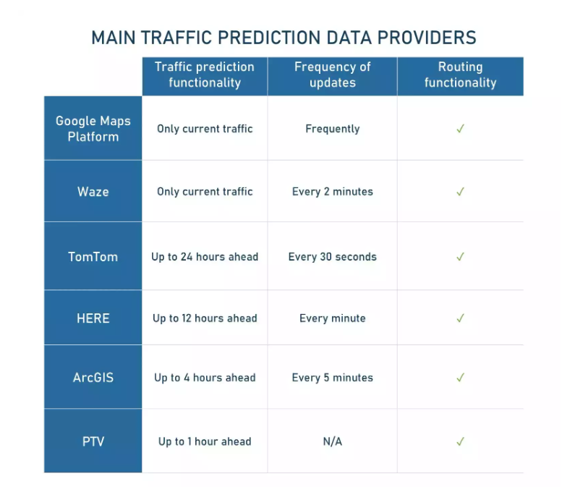All the analytics solutions only offer predictions for the near future. Short-term forecasts are obviously more accurate than long-term ones as there’s always a chance of unforeseeable circumstances on the road.

The proposed solution uses Machine Learning Algorithms. Machine learning (ML) allows us to create predictive models that consider large masses of heterogeneous data from different sources. Various ML algorithms were used and compared to find out the algorithm that gives the best accuracy range.

Further additions that can be done:

1. Right now, the project is processing an amount of historic data, we can make it to process real-time data to give the desired output.
2. ML/DL algorithms work best when there is sufficient data to train the models and fine-tune them to achieve maximum accuracy. So, the bigger datasets the better results we will get.

## Code submission (GitHub link)

<https://github.com/NandiniPareek/upskill_campus/blob/main/Smart_City_Traffic_Forecasting.ipynb>

## Report submission (GitHub link):

<https://github.com/NandiniPareek/upskill_campus>

# Proposed Design/ Model

Simple neural networks are not suitable for solving sequence problems as in addition to current input, track of previous inputs should also be kept. Neural Networks with some sort of memory are more suited to solving sequence problems. Recurrent Neural Networks (RNN) have been proven to efficiently solve sequence problems. LSTM (Long Short-Term Memory), which is a variation of RNN is one such network.

This sequential model was trained on X_train and y_train with batch size of 120 and a total of 100 epochs. The final accuracy after 100th epoch was 95.87%.

Different classification algorithms were tried.

1. Random Forest gave an accuracy score of 93.64.
2. Decision Tree gave an accuracy score of 500.00.
3. Support Vector Machine gave an accuracy score of 41.31.
4. XGBoosting gave an accuracy score of 226.75.

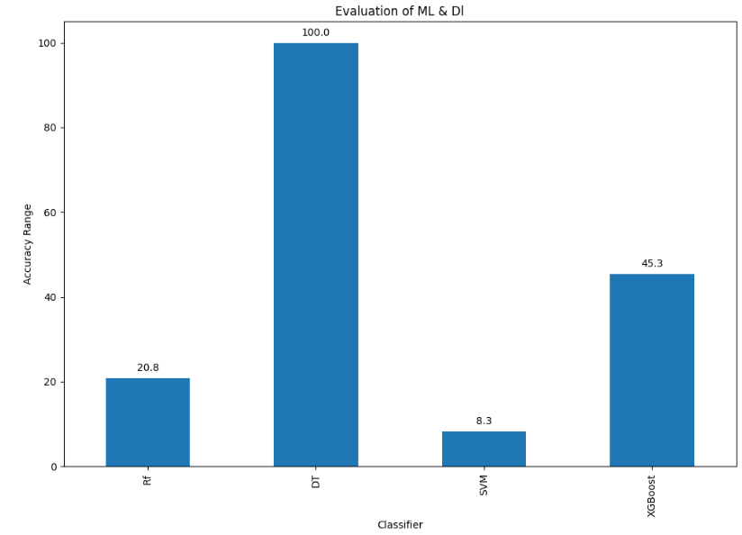Comparing all of them

# Performance Test

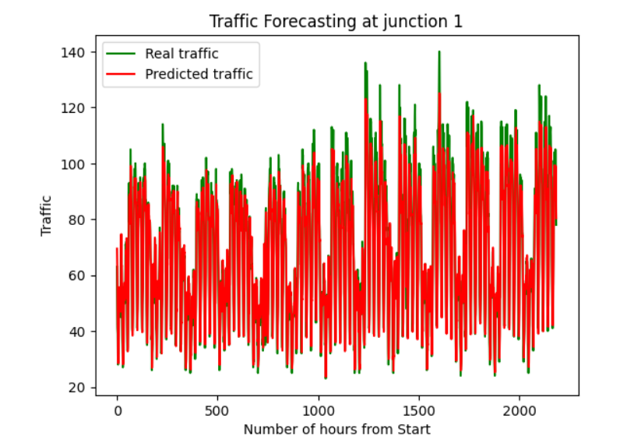The model was tested for predicting the traffic at the 4 junctions:

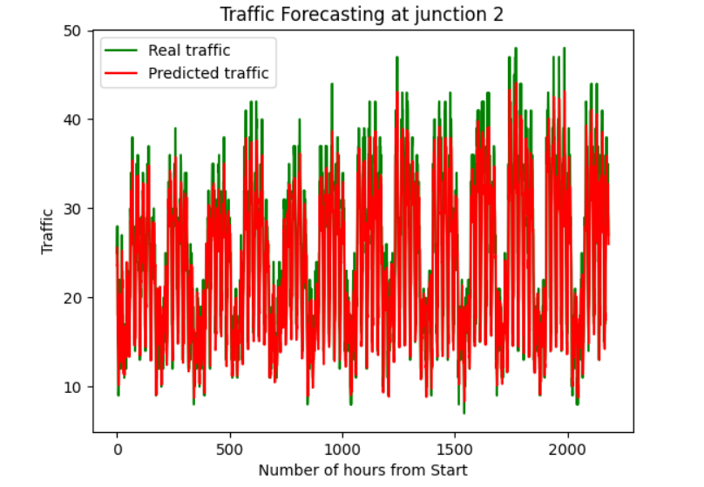

# 

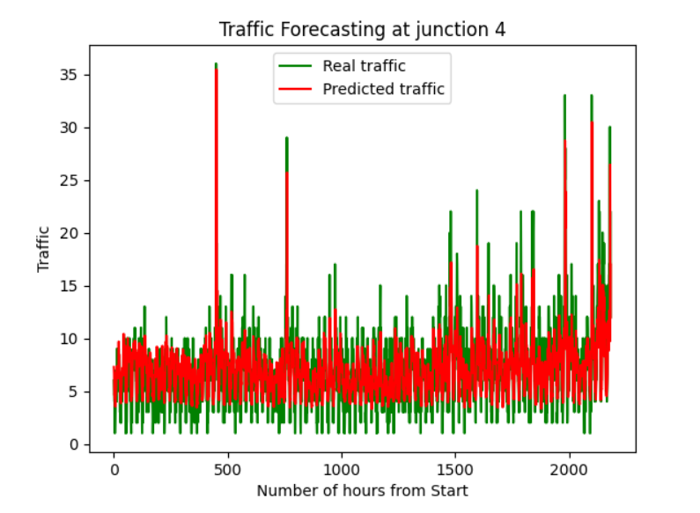

# My learnings

This internship gave me a very good opportunity to get exposure to Industrial problems and design/implement solution for that. It was an overall great experience to have this internship.

It also helped me in understanding the Data Science and Machine Learning field better, which will play a significant role in shaping my career.

# Future work scope

There is always a scope for betterment. The solution provided can be developed further for many different functionalities and features. Few of them are listed below:

1. Right now, the project is processing an amount of historic data, we can make it to process real-time data to give the desired output.
2. ML/DL algorithms work best when there is sufficient data to train the models and fine-tune them to achieve maximum accuracy. So, the bigger datasets the better results we will get.
3. It can also be trained on the same dataset further for better accuracy.